onfigure Squirrel SQL to connect to IBM DB2

"[Squirrel SQL](http://www.squirrelsql.org/)" is a great light weight generic SQL client that I have started using for more than 7 years now.  
  
This is how to configure Squirrel SQL 3.3.0 to connect to DB2 server, I have installed IBM DB2 admin client 9.7 - 64 bit software on my Windows 7 enterprise SP1. You will find two types of DB2 drivers APP & NET, most recommended way is to use type 4 JDBC driver (thin) that actually doesn't require client installation, but require proper jar files and associated license.  
  
**Steps:**  
1- Open Driver list from left menu, click the plus sign "Create a New Driver".  
2- Type "IBM DB2 Universal Driver" in "Name" textbox.  
3- Type "jdbc:db2://<server>:<port>/<dbname>" in "Example URL" textbox.  
4- Type "com.ibm.db2.jcc.DB2Driver" in "Class Name" editable dropdown list.  
5- Click "Extra Class Path" tab.  
6- Click "Add" and select two jar files from %DB2_INSTALL%\java\db2jcc.jar & %DB2_INSTALL%\java\db2jcc_license_cu.jar  
7- Click Ok, and we are done defining the driver.  
8- Now create an alias for the DB using previous driver and providing URL, username, & password.  
  
Your driver dialog should look like:

[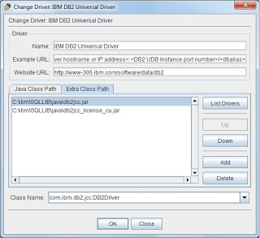](http://2.bp.blogspot.com/-qafI1vB9h_E/Ty9oj8wOjCI/AAAAAAAAAC8/95AB2kjKHkY/s1600/db2-universal-driver-squirrel-sql.jpg)